Seminar 2 Report: Three-Phase Full Bridge Rectifier
Hou Zhuo 2186113627
PART I

Topic
Understand three-phase full bridge rectifier by simulation.

Simulation Model
In this part, the simulation is based on three-phase full bridge rectifier (thyristor) with inductive load. We was assigned with a set of parameters (L, R, E) as well as phase-shifting angle α based on which our jobs include:
  - Basic analysis of the simulation:
- Whether the system works under Rectification Mode (AC/DC) or Active Inversion Mode (DC/AC)
- The sequence of driving signal of each thyristor
- The ON and OFF state of each thyristor
  - Theoretical calculations of:
- Average value of DC-link voltage V_{d}
- Average value of DC-link current I_{d}
- RMS value of AC side current
- RMS value of the current flowing through a Thyristor
  - Comparison between theoretical results and simulation results

2.1 Simulation model 1

This model is established to find out the functioning state of three-phase full bridge rectifier circuit in the rectification mode.
Fig 1-1, rectification mode of three-phase full bridge rectifier circuit

The following figure shows our simulation model implemented in Simulink.
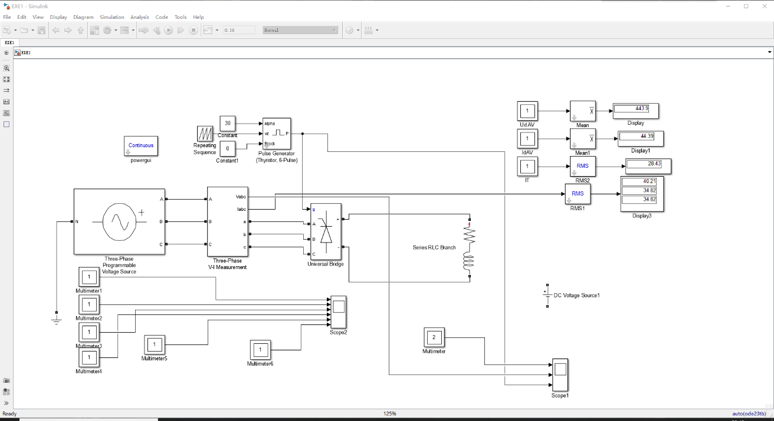
Fig 1-2 rectification mode of three-phase full bridge rectifier circuit in simulation
The simulation circuit is shown in the picture above. The upper right-hand corner of the image shows average value of DC-link voltage V_{d}, average value of DC-link current I_{d}, RMS value of the current flowing through a Thyristor I_{VT1} and RMS value of AC side current.

2.2 Simulation model 2

This model is established to find out the functioning state of three-phase full bridge rectifier circuit in the active inversion mode.
Fig1-3 active inversion mode of three-phase full bridge rectifier circuit
The following figure shows our simulation model implemented in Simulink. 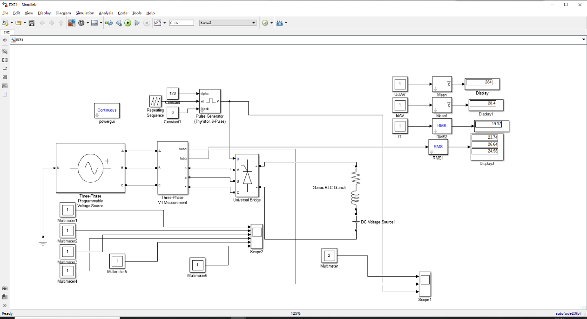
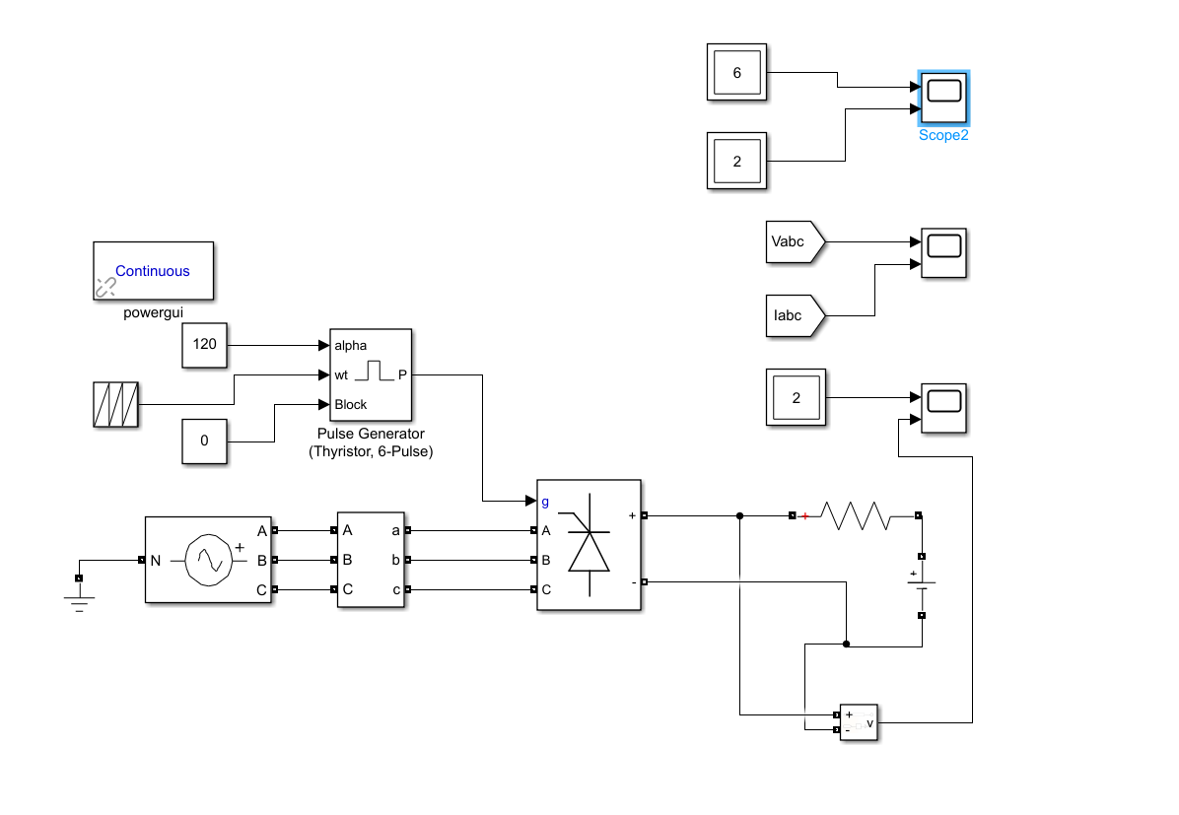
Fig.1-4 active inversion mode of three-phase full bridge rectifier circuit in simulation

There are two major difference in this circuit compared to the first model. Firstly, we add a counter electromotive source in series connection with the resistance and the inductance, which is emphasized in the model. Another adjustment we made is resetting the triggering angle to$a_{2}$.
3. Parameter Setup
In this part, the AC side three-phase voltage source has the following specifications for both the first and the second simulation model:
RMS Value of Phase-To-AC-Neutral-Point Voltage: 220V
(i.e. RMS Value of Line-To-Line Voltage: 380V)
Line Frequency: 50Hz
According to the requirement of the three-phase voltage source, the peak value of voltage for each phase was set to 311V, which is nearly equal to$\sqrt{2}×220V$, where frequency of all three sources is same value of 50Hz.
With the consideration of parameters of firing angle $a_{1}, a_{2}$ , as well as $L, E, R$our group were assigned, those fixed parameters are listed below as a reference.
Table 1-1 Other parameters settings in simulation model of three-phase full bridge rectifier
L | R | E | $$a_{1}$$ | $$a_{2}$$
2mH | 10Ω | -540V | 30° | 120°

4. Simulation Results
4.1 Simulation results 1
These screenshots of the scope demonstrate ten figures of signal waveform. The first figure shows the voltage and current of Series RLC Branch. The second figure shows the voltage of phase-to ground. The third figure shows the signal of pulse generator. And the last six figures show the voltage of six thyristors.
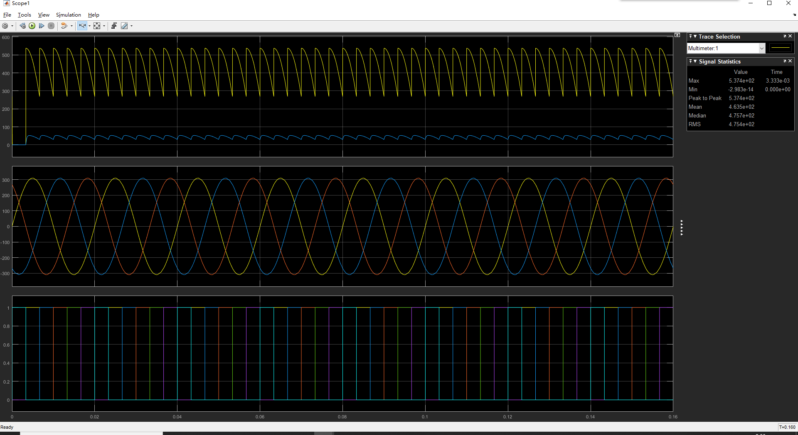
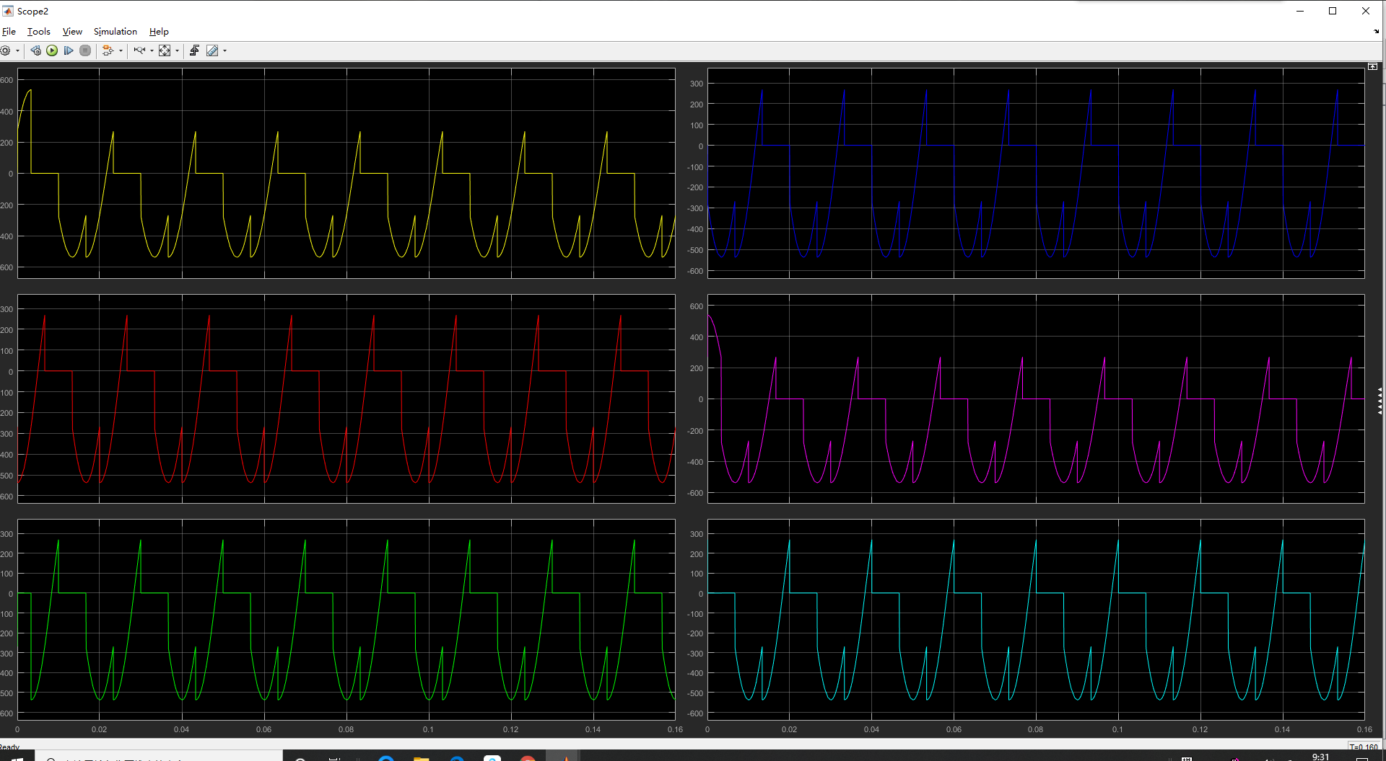
By the Display component in Simulink, it is not difficult to get the average and effective value of any given signal. Here list the results.

Table 1-2 results in model 1
U_{d}(V) | I_{d}(V) | RMS value of AC side current(A) | I_{VT1}(A)
443.9 | 44.39 | 40.21 ; 34.82 ; 34.83 | 28.43
4.2 Simulation results 2
Similarly, these screenshots of the scope demonstrate several figures of signal waveform of the second circuit, which functions in active inversion mode. The first figure shows the voltage and current of Series RLC Branch. The second figure shows the voltage of phase-to ground. The third figure shows the signal of pulse generator. The fourth figure shows the mixture of six-thyristor voltage. The next shows the voltage and current of VT₁. And the last six figures show the voltage of six thyristors separately.
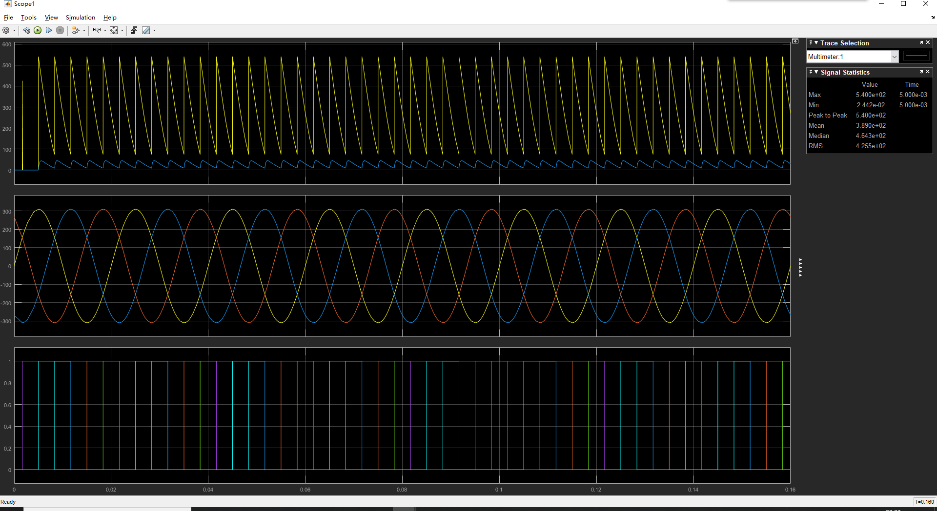
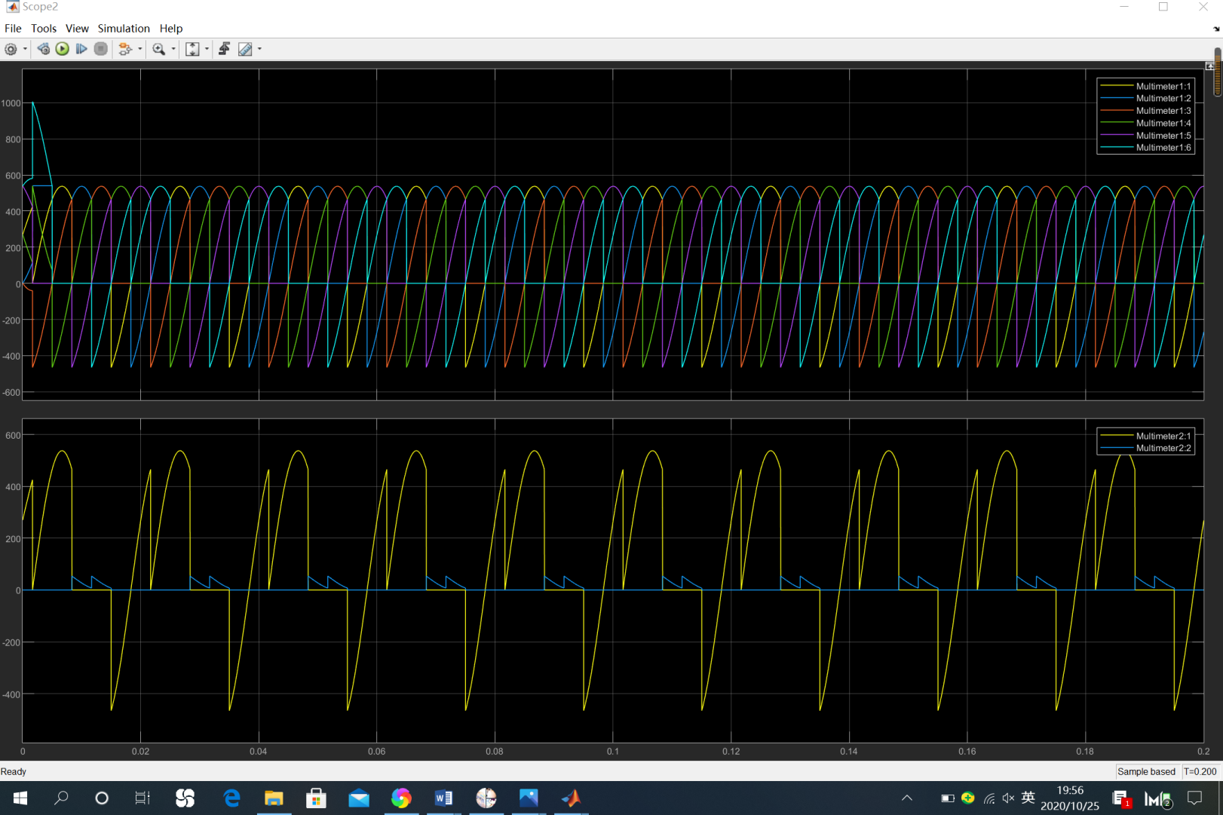
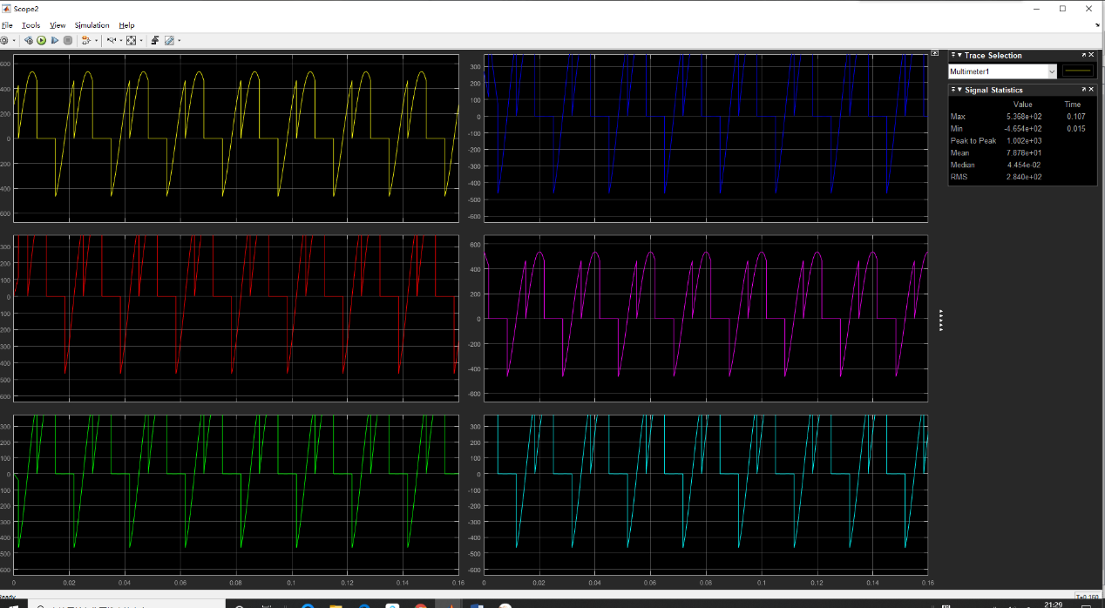
By the ‘Display’, we obtain the measurement data of the signals below.
Table 1-3 several statistics data of shown signals in model 2
U_{d}(V) | I_{d}(V) | RMS value of AC side current(A) | I_{VT1}(A)
284 | 28.4 | 23.74 ; 26.65 ; 24.58 | 19.37

Analysis of the Results
5.1 Simulation analysis 1
Primarily, let’s discuss the working state of the circuits. For the first model, there’s no counter electromotive source at the load terminal, so the circuit works in rectification mode when the triggering angle$α={30}^{0}$.
The results of simulation in the above illustrates the waveforms of driving signal of each thyristor and current flowing through them.
In those figure the stimulating signal for six thyristors are displayed in order, from VT1 to VT6. As we can see, all thyristors are triggered periodically. The triggering signals obey the rule that two thyristors are triggered at one time, and the sequence of triggering is VT6&VT1—VT1&VT2—VT2&VT3—VT3&VT4—VT$&VT5—VT5&VT6.
And it also illustrates the waveform of currents through the thyristors and the waveform of output voltage together.
Theoretical calculations for the first model are listed here.
Table 1-4 theoretical calculations result of model 1
Triggering angle |  | $${30}^{o}$$
Average value of  DC-link voltage Vd |  | 445.83V
Average value of  DC-link current Id |  | 44.583A
RMS value of AC side current |  | 36.402A
RMS value of the current flowing through a Thyristor |  | 25.740A
Then it is the time to make comparison between simulation result in table 1-2 and theoretical calculation result.
Table 1-5 Comparison between theoretical results and simulation results result of model 1
Rectification Mode$α={30}^{0}$
theoretical equation | Theoretical results | simulation results | Error in percentage
 | 445.83V | 443.9V | 0.43%
 | 44.583A | 44.39A | 0.43%
 | 36.402A | 36.62A | 0.60%
 | 25.740A | 28.43A | 10%
Three visible reasons in the simulation could probably cause difference. The most vital one is that there are some snubber resistance and snubber capacitor in the integrated three phase bridge we used. Besides, the thyristors which are considered as ideal devices in theory were not able to be treated as ideal ones. At last, the inductance we used in theoretically infinitely large where them are not so large in simulation process.
5.2 Simulation analysis 2
Primarily, let’s discuss the working state of the circuits. For the second model, there exists a counter electromotive source at the load terminal, so the circuit has to work in active inversion mode when the triggering angle$α={120}^{0}$.
The results of simulation in the above illustrates the waveforms of driving signal of each thyristor and current flowing through them.
In those figures, the stimulating signal for six thyristors are displayed in order or their label, from VT1 to VT6. As we can see, all thyristors are triggered periodically. The triggering signals obey the rule in model 1, that two thyristors are triggered at one time, and the sequence of triggering is VT6&VT1—VT1&VT2—VT2&VT3—VT3&VT4—VT$&VT5—VT5&VT6.
And it also illustrates the waveform of currents through the thyristors and the waveform of output voltage together.
Theoretical calculations for the first model are listed here.
Table 1-6 theoretical calculations result of model 2
Triggering angle
Average value of  DC-link voltage Vd | $$U_{d}=-2.34U_{2}\cos\left(π-a\right)$$ | -257.4V
Average value of  DC-link current Id |  | 28.26A
RMS value of AC side current |  | 23.07A
RMS value of the current flowing through a Thyristor |  | 16.32A
Then we make comparisons between simulation result in table 1-3 and theoretical calculation result.
Table 1-7 Comparison between theoretical results and simulation results result of model 1
Active Inversion Mode
theoretical equation | Theoretical results | simulation results | Error in percentage
$$U_{d}=-2.34U_{2}\cos\left(π-a\right)$$ | -257.4V | -284V | 10%
 | 28.26A | 28.4A | 0.50%
 | 23.07A | 24.99A | 8.3%
 | 16.32A | 19.37A | 19%
Three visible reason in the simulation could probably cause the difference or error. The most vital one is that there are some snubber resistance and snubber capacitor in the integrated three phase bridge we used. Besides, the thyristors which are considered as ideal devices in theory were not able to be treated as ideal ones. At last, the inductance we used in theoretically infinitely large where them are not so large in simulation process.

PART II
- Topic
Study uncontrolled three-phase full bridge rectifier supplying RC load by simulation
- Simulation model
In this part, the simulation is based on three-phase full bridge rectifier (diode) with capacitive load. We was assigned with different capacitance for DC side capacitor. It is required to carry out simulation and analyze how the variations of load resistor RL would influence the following items: Output voltage, Power factor ,THD.
Fig. 2-1 Diode Bridge with Capacitive Load
The following model in Simulink is established to figure out the working conditions of three-phase full bridge rectifier (diode) with capacitive load. We add a capacitor in parallel connection with load resistance, which is also marked in the figure.
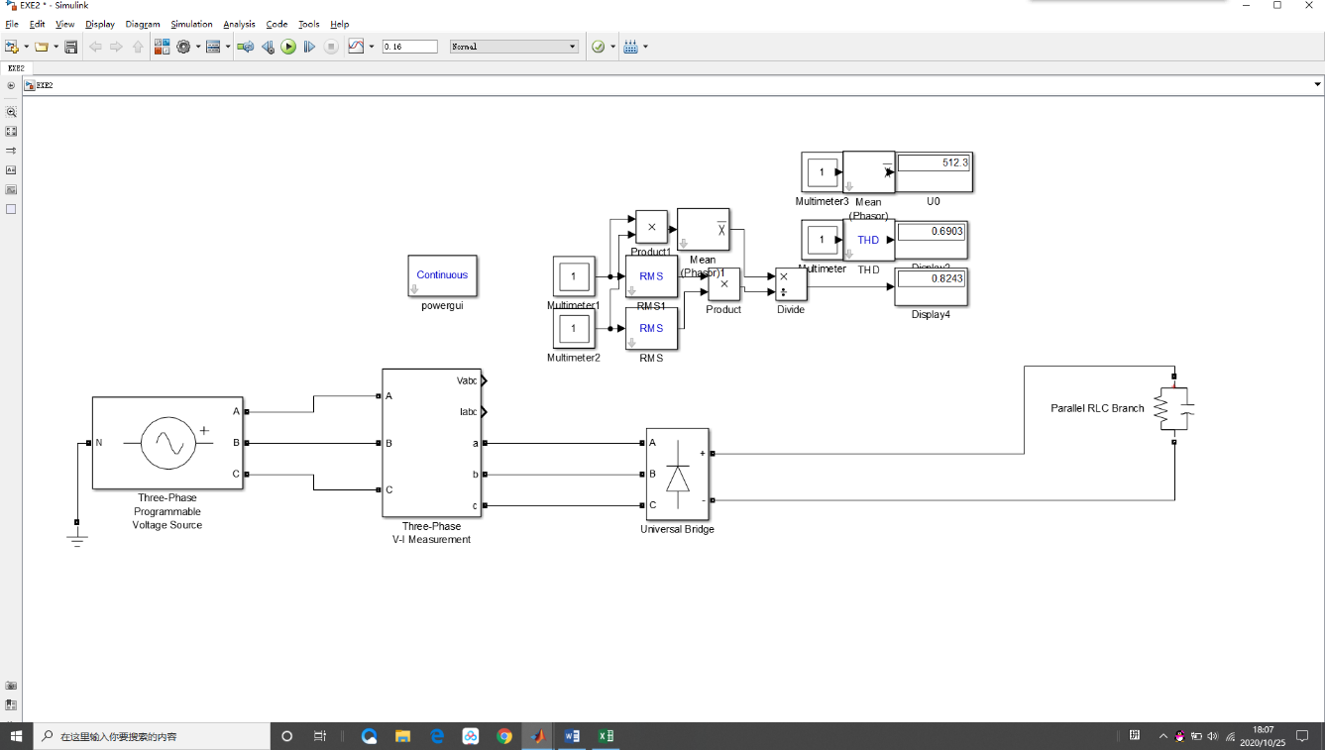
Fig. 2-2 diode bridge with capacitive load circuit in simulation
For the measurement of power factor, we used several components in ‘Math Operations’. The main mechanism of this method is that $PF=\frac{P}{S}$ .

Parameters setup
In this part, the AC side three-phase voltage source remains the same specifications as those in PART 1, with a phase voltage of approximately 311V and 50Hz line frequency.
Diode bridge circuit has no need to set triggering angle, but we still need to set the valve of capacitance and resistance. Considering about the data in appendix, we get a capacitor of 7.5 mF, and a set of resistance is listed in the figure.
Table 2-1 a set of resistances with typical values
Name | R1 | R2 | R3 | R4 | R5 | R6 | R7 | R8 | R9 | R10 | R11 | R12 | R13
Value/Ohm | 0.1 | 0.5 | 1.0 | 1.5 | 2.0 | 2.5 | 3.0 | 5.0 | 6.0 | 7.0 | 8.0 | 9.0 | 10.0
- Simulation results
The capacitor plays a vital role in this circuit. When a couple of diodes were conducted, output DC voltage equals to the largest line voltage of AC side. Not only does the voltage charge the capacitor, it is also consumed by the load. On the other hand, if none of the diodes is conducted, the capacitor will discharge to the load while output voltage will drop exponentially.
Next we managed to provide the following plots: Vo = f(R_{L})，PF = f(RL),THD = f(R_{L}). What we finally did is choosing 13 typical values for RL and get the corresponding steady-state values for Vo, power factor and THD with Simulink.
Table 2-2 output voltage, power factor and THD with corresponding resistance
R | Output voltage | Power factor | THD
0.1 | 503 | 0.9979 | 0.2359
0.5 | 511 | 0.942 | 0.7222
1.0 | 512.3 | 0.8243 | 0.6903
1.5 | 514.1 | 0.745 | 0.581
2.0 | 516.2 | 0.6933 | 0.546
2.5 | 518 | 0.6529 | 0.5697
3.0 | 519.6 | 0.6228 | 0.6111
5.0 | 524.2 | 0.5515 | 0.7703
6.0 | 525.8 | 0.5275 | 0.8432
7.0 | 527 | 0.5083 | 0.9103
8.0 | 527.9 | 0.4926 | 0.9532
9.0 | 528.7 | 0.4784 | 1.018
10.0 | 529.4 | 0.4666 | 1.065
- Analysis of the results
After we had got the data in table2-2, we stored the data in corresponding vectors and later plotted them in MATLAB.
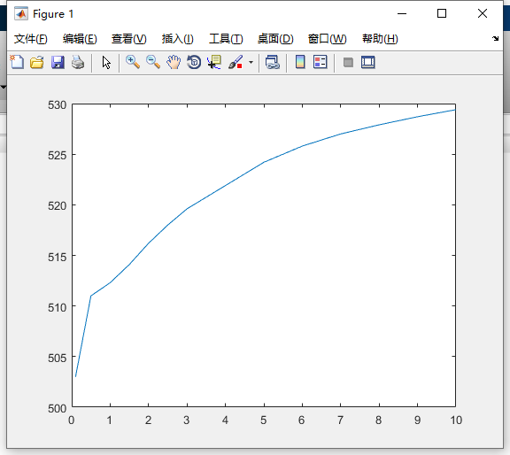
Fig2-4 relationship between resistor value and power output voltage
The first figure illustrated relationship between resistor value and power output voltage. As it was shown in the figure, the average value of output voltage rises rapidly when the resistance is relatively small. As the resistance grows, the acceleration of output voltage drops.
For a specific circuit in application, the value of resistor represents the weight of the load. The average of output voltage decreases with the growth of load. After the index $ωRC$is bigger than$\sqrt{3}$, the value of U_{d} will remain a constant value, which is 2.34U₂.
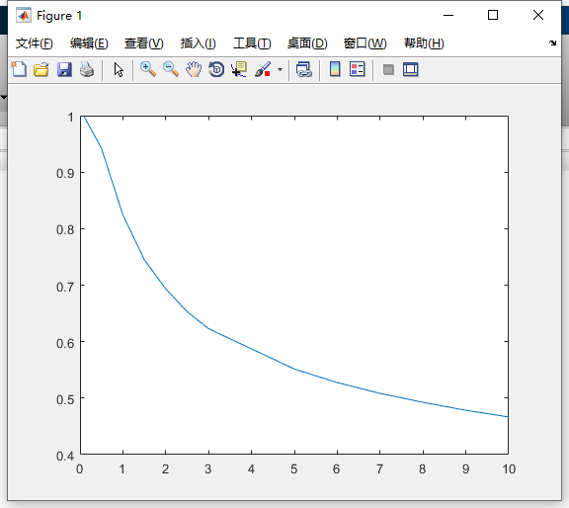
Fig. 2-5 relationship between resistor value and power factor
The figure above demonstrates how the power factor varies with the resistance. The trend of variation is that the power factor declines with a lighter load namely a bigger resistance.
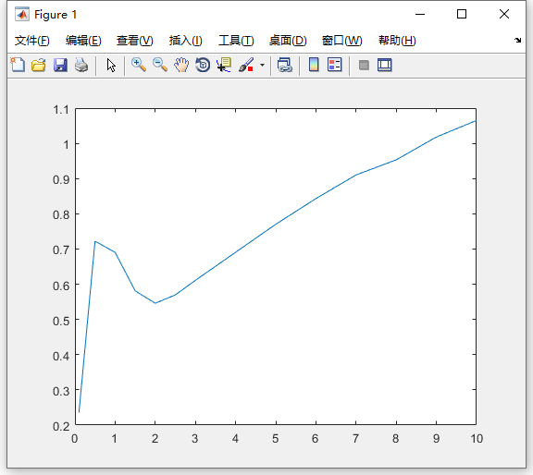
Fig.2-6 relationship between resistor value and power factor
This figure displays the tendency of THD changes with the resistance. Generally speaking, the ratio of harmonics over fundamental wave is not fixed. The general trend is that the heavier the load is, the larger the THD is.

